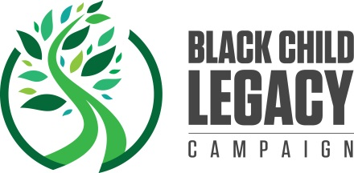

Black Child Legacy Campaign
Communication Contractor Application
Organization Name:
Primary Contact Name:
Contact Title:
Contact Email:
Mailing Address:
Phone:
Website:
EIN:
Target Neighborhood (if applicable):
Communication services provided:
Website Design/Maintenance
Social Media
Please list platforms:
Public Relations
Photography
Videography
Podcasts
Graphic Design
Other
Please answer the following questions. Space will expand as you type.
Please describe your services:
Please describe your knowledge of the Black Child Legacy Campaign:
Please describe your connection to our target audience:

